May 29, 2022

Watch RidgeKids Online for May 29th. “Creation, day 7.”

“Our bible story today finished up our lessons about all the things God made. On day 7 of creation God rested from His work. He saw everything that He had made and declared that it was good.”

What good things has God made. (People, earth, animals etc.)
What did God do on day seven? (He rested)
Who made everything? (God made everything)

We learned about what God did on day 7 of creation. Let’s stretch really big and then pretend to take a nap. Ah..it feels good to rest! Now let’s say our memory verse.

“God (point up) saw everything he had made. (Binocular hands, look around) And it was very good,’ (thumbs-up) Genesis 1:31.” (Open hands like a book.)

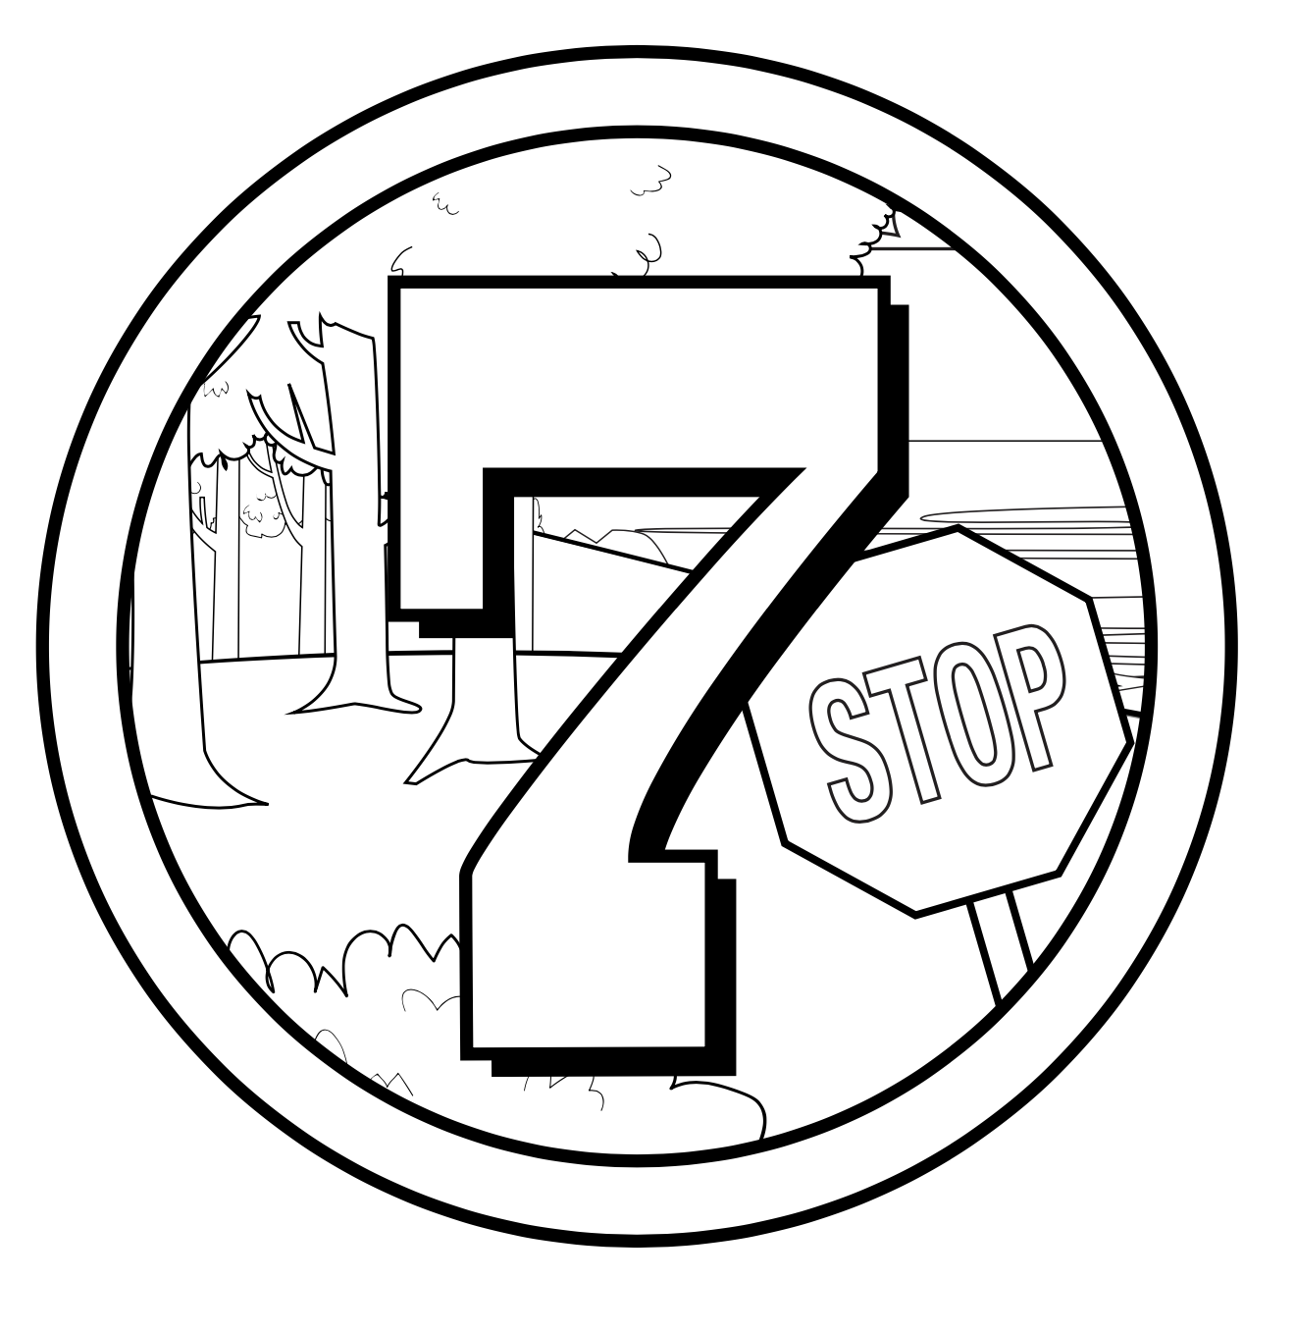

God Rested
Genesis 1:1-2:3

