Watch RidgeKids Online for May 22nd. “Creation, day 6.”

“In our bible story this month, we learned that God made the whole world and everything in it. On day one, God made the light and dark. On day two, God made the sky and water. On day three, God made the sun, moon, and stars. On day four, He made the land, plants, and seas. On day five, God made the birds and fish. Today we heard about what He made on day 6.

What did God make on day six? (Animals & People)
Who made everything? (God made everything)

We learned about what God made on day 6 of creation. Let’s pretend to be our favorite animals! Great job! Now let’s say our memory verse.

“God (point up) saw everything he had made. (Binocular hands, look around) And it was very good,’ (thumbs-up) Genesis 1:31.” (Open hands like a book.)

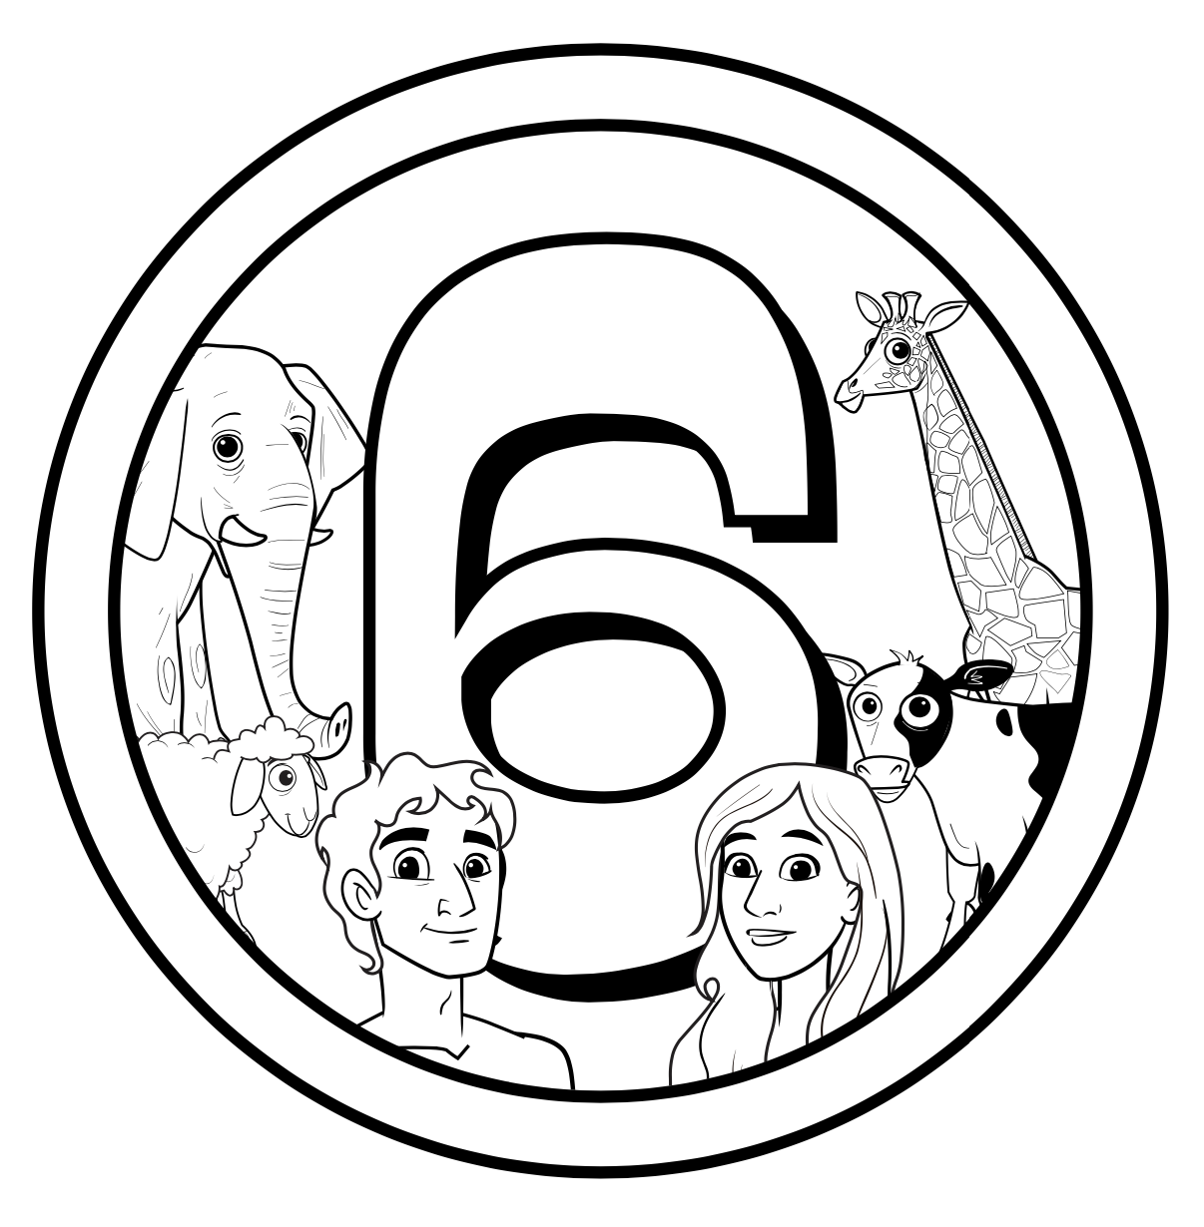

Animals & People
Genesis 1:24-31

