May 15, 2022

Watch RidgeKids Online for May 15th^{t}. “Creation, day 5.”

“In today’s story, we heard more about some things that God created. Today we learned that God created birds and fish on day 5 of creation. Count to five with me. 1..2..3..4..5..”

Great job counting!!

What did God make on day five? (Birds & Fish)
Who made everything? (God made everything)

We learned about what God made on day 5 of creation. Let’s flap our arms like a bird or swim like a fish. Now let say our memory verse.

“God (point up) saw everything he had made. (Binocular hands, look around) And it was very good,’ (thumbs-up) Genesis 1:31.” (Open hands like a book.)

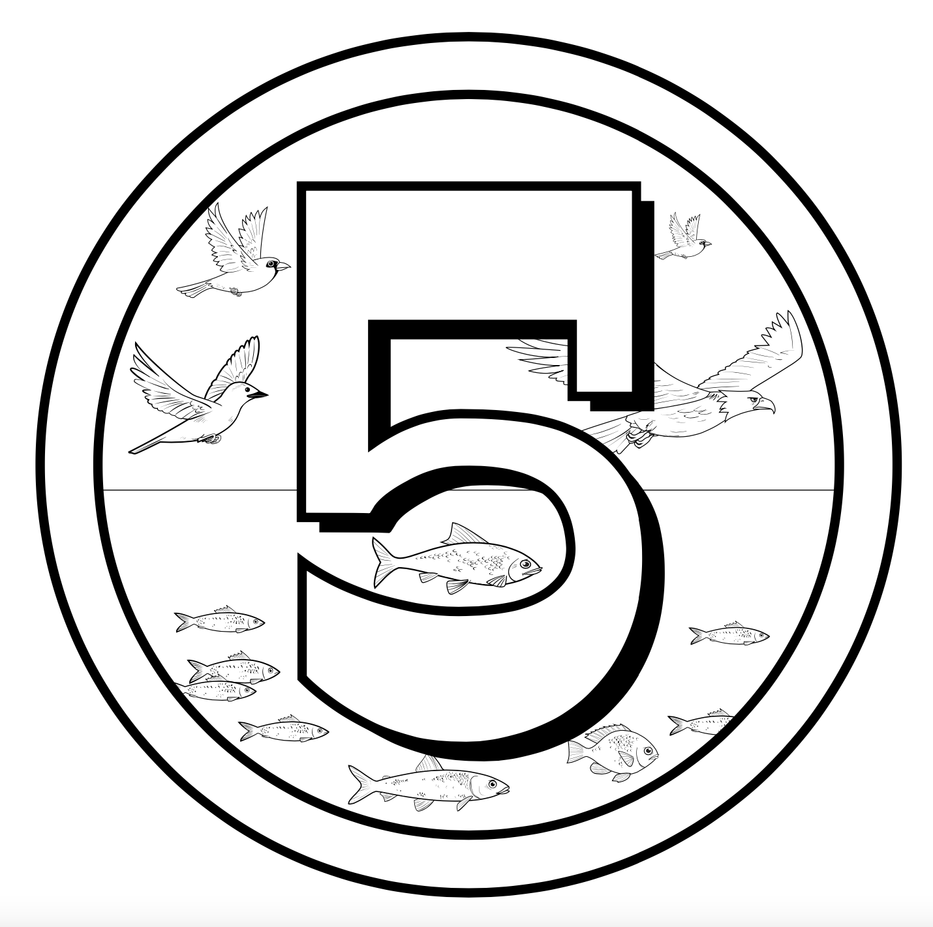

Birds & Fish
Genesis 1:20-21

