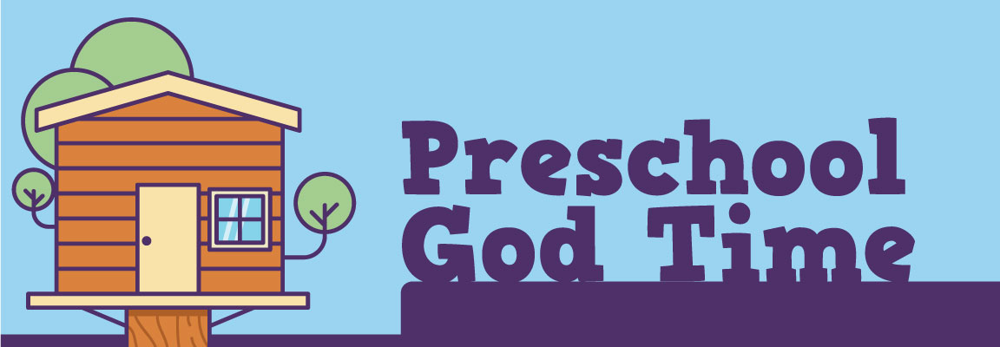
September 19, 2021

Watch RidgeKids Online for September 19th, “Rahab and the Spies.”

In our story this week, we heard about a lady named Rahab who helped hide and get the two spies from God’s army out of the city of Jericho. If she was caught hiding the spies, she would have been in big trouble. Rahab had heard about God and knew that He could do amazing things. This gave her courage. The spies told Rahab to hang a red rope outside her window, and they would make sure her, and her family were safe. Sometime later when God’s army came to battle the city of Jericho, they saw the red rope and remembered Rahab. They made sure to keep her and her family safe. God was with Rahab all along.

Who helped hide the two spies? (Rahab)
What did she hand outside of her window? (a red rope)
Who is always with you? (God is always with me!)

Hang something red on your bedroom door. It can be a piece of yarn, a sock, shirt, or anything you have. Now, go inside your room and save your verse. Now stand in your open doorway and say your verse. Last, say your verse outside of your bedroom with the door closed.

“We have (bend wrists and tap fingertips to chest) the Lord our God (point up) to help us (right thumbs-up on top of left palm) 2 Chronicles 32:8 (Open hands like a book.)

Color Rahab and then use a red marker or crayon to draw a red rope in her hand.

