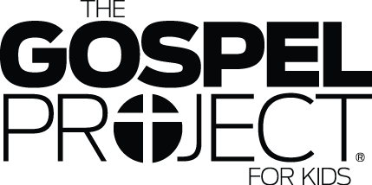

Watch the story, “Jesus’ Triumphal Entry” on the RidgeKids Teays Valley Facebook group, YouTube or at riverridge.tv/ridgekidsonline

**Prayer:** Lord, you reign as King. Even though I can’t see you now, help me to remember that you are our King on the throne in heaven. Amen.

**May 22, 2022**

**Read the story “Jesus Triumphal Entry”**

K-1st: Read p. 246 of The Big Picture Interactive Bible Storybook

2nd-5th: Read Matthew 21:1-17

**Draw a line to match the statement on the left to the answer on the right.**

A special time to remember how God saved His people from Donkey

slavery in Egypt

Jesus said they would find this animal tied up in the village Rocks

The word that means “save now” that the people said Passover

when Jesus entered Jerusalem

Jesus said that the _______would praise Him if the people King

did not.

The people welcomed Jesus when he entered Jerusalem Hosanna

and said he was _____________.

**Prayer:** Jesus, you truly are out King. We praise you for who you are! Amen.

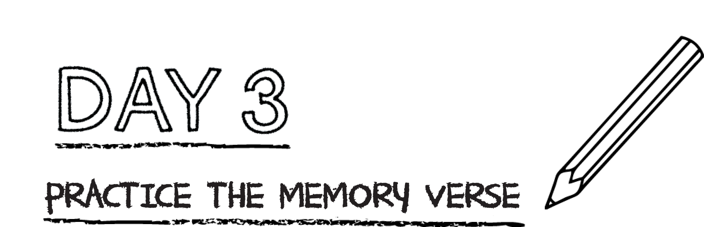



**Write the new memory verse on the blanks below.**

*“He humbled himself by becoming obedient  
to the point of death—even to death on a cross.” Philippians 2:8*

**___________________________________________________________________________**

**___________________________________________________________________________**

**___________________________________________________________________________**

**___________________________________________________________________________**

**Prayer:** Dear Jesus, you humbled yourself to die on a cross for my sin. Thank you so much Lord for giving your life for mine. Amen.

*.*

*During Jesus’ triumphal entry, the people welcomed Him as King. Jesus was the Messiah spoken about by the prophet Zechariah: “Look, your King is coming to you; he is righteous and victorious, humble and riding on a donkey, on a colt, the foal of a donkey” (Zechariah 9:9). One day, Jesus will return to earth on a white horse as King over everything*

***Fill in the blanks below to complete the prayer.***

*Dear Jesus,*

*Help me to live a life that praises you so that the rocks don’t cry out! Jesus, you*

*are our ______________________. You are _______________, _____________________,*

*and_______________________. I praise you for who you are. Amen.*