

Watch RidgeKids online, “Hosea, Prophet to Israel” on the RidgeKids Teays Valley Facebook group or at

https://riverridge.tv/ridgekidsonline

**Prayer:** Dear God, thank you for your deep love for us. Even though we sin over and over, you never give up on us. Amen.

**Answer the following questions true or false.**

_____1. God told Hosea to marry a woman who would not be faithful to him.

_____2. Hosea and his wife had 5 children.

_____3. Gomer was Hosea’s wife. She was a faithful wife.

_____4. Their children had names that meant blessings to Israel.

_____5. Hosea called for the people to repent and turn back to Israel.

_____6. Just like Hosea’s love for Gomer was deep, God’s love for us is deep and he never gives up on us.

**Read the story “Hosea, Prophet to Israel”**

K-1st: Read page 106 from the Big Picture Interactive Storybook Bible.

2nd-5th grade: Read Hosea 1:3-8, 6:1-2 in the Big Picture Interactive Bible.



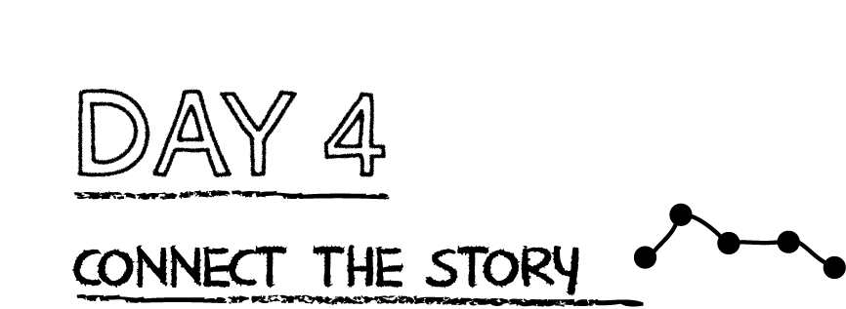

**Challenge your child to practice the memory verse by filling in the words from 2 Peter 3:9 with only the first letter of each word provided. Parents may assist younger children in writing! (use the HCSB version)**

T_________ L______________ d__________ n_________ d___________ h_________

p_____________________, a________ s_______________ u_____________________

d__________________, b____________________ i_______ p____________________

w______________ y_____________ n___________ w__________________________

a____________________________ t____ p________________________.

**Prayer:** Dear God, thank you so much for being patient with me. Amen.

God used Hosea’s unfaithful wife to show the people of Israel that they were unfaithful to Him. God gave Hosea a deep love; Hosea was willing to buy back Gomer even after all she had done. God’s love is deep, and it never gives up. He goes after His people and paid a great price to get us back.

**Read 1 Peter 1:18-19.**

What does this verse say was NOT the payment for our sin?

__________________________________________________________________________

What was the payment for our sin?_________________________________________

Which is more costly? Silver and Gold or Jesus’ blood? (Circle one)

**Say a prayer to God thanking him for paying such a great price to save us.**